**Lab 3 Report**

Benjamin Hayden

Will Elmore

Chris Hack

Derek Allison

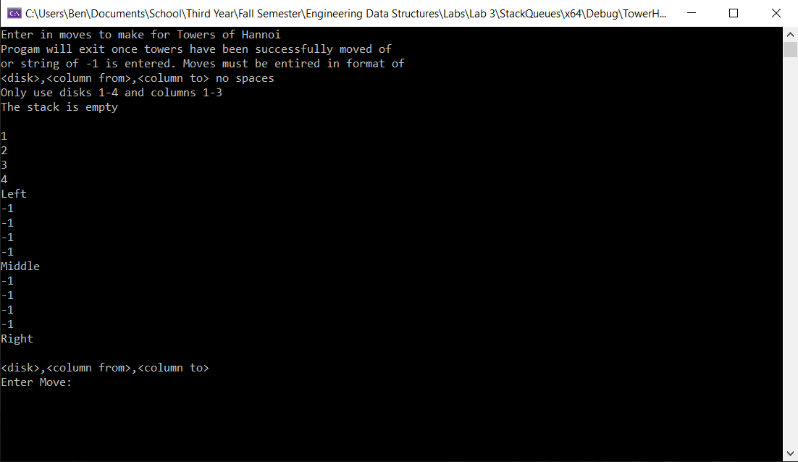

Figure : Running

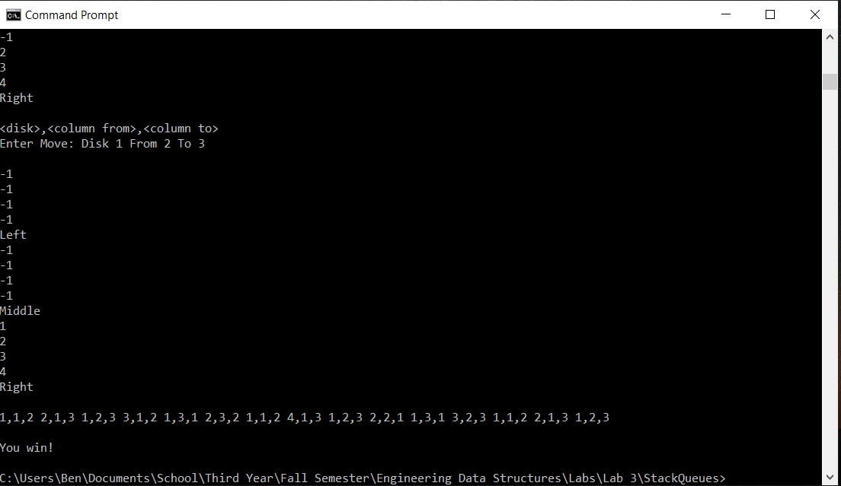

Figure : Win Case

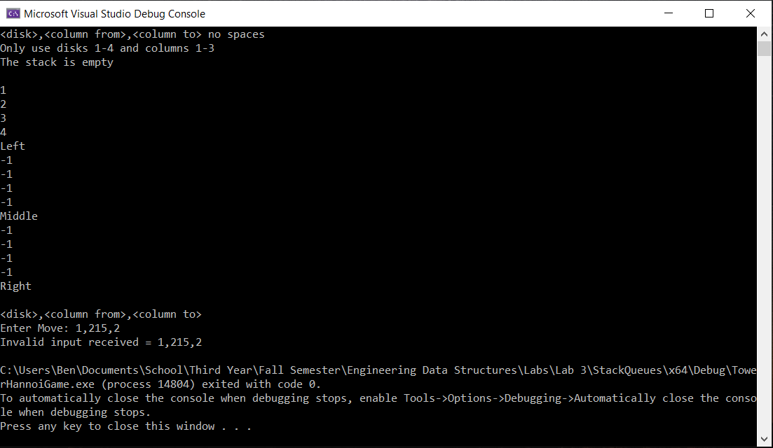

Figure : Invalid Number

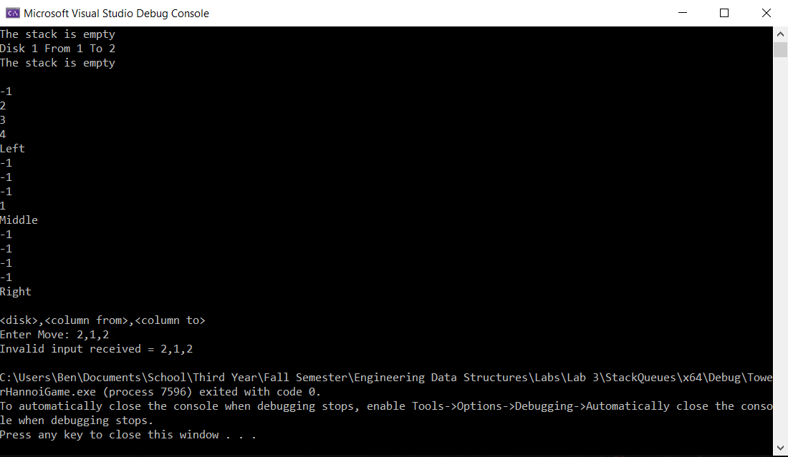

Figure : Invalid Move

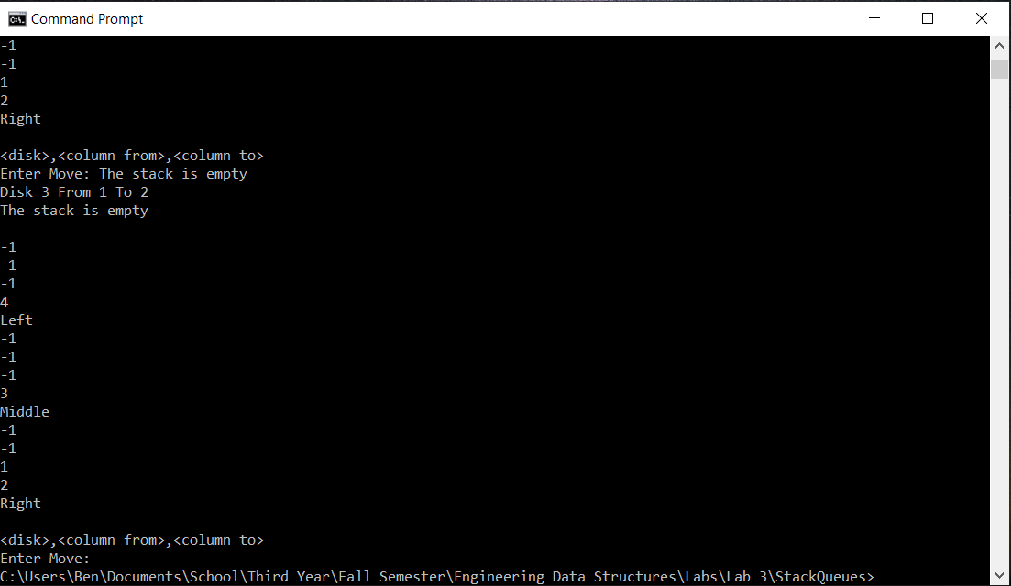

Figure : Output of moves.txt